**National University of Computer & Emerging Sciences, Karachi**

**Computer Science Department**

**Fall 2022, Lab Manual - 07**

|  |  |
| --- | --- |
| **Course Code: CL-1004** | **Course : Object Oriented Programming Lab** |
| **Instructor(s) :** | **Shahroz Bakht** |

# Contents:

1. Introduction to Polymorphism
2. Types of Polymorphism
3. Lab Tasks

# INTRODUCTION TO POLYMORPHISM

The word polymorphism means having many forms.

* Typically, polymorphism occurs when there is a hierarchy of classes and they are related by inheritance.
* C++ polymorphism means that a call to a member function will cause a different function to be executed depending on the type of object that invokes the function.

## Real World Example:

* A real – life example of polymorphism is that a person at the same time can have different characteristics. A man at the same time is a father, a husband, an employee, so the same person possesses different behavior in different situations. This is called as polymorphism.
* Polymorphism is considered as one of the important features of Object Oriented Programming.

# TYPES OF POLYMORPHISM:

In C++ polymorphism is mainly divided into two types:

* Compile time Polymorphism
* Runtime Polymorphism

## Image result for diagram for polymorphism in c++

## Compile time Polymorphism:

### This type of polymorphism is achieved by function overloading or operator overloading.

## Function Overloading:

* When there are multiple functions with same name but different parameters then these functions are said to be overloaded.
* Functions can be overloaded by a change in the number of arguments or/and change in the type of arguments.

## Example Code for Function Overloading:

// C++ program for function overloading

#include <bits/stdc++.h>

using namespace std;

class Geeks

{

public:

// function with 1 int parameter

void func(int x)

{

cout << "value of x is " << x << endl;

}

// function with same name but 1 double parameter

void func(double x)

{

cout << "value of x is " << x << endl;

}

// function with same name and 2 int parameters

void func(int x, int y)

{

cout << "value of x and y is " << x << ", " << y << endl;

}

};

int main() {

Geeks obj1;

// Which function is called will depend on the parameters passed

// The first 'func' is called

obj1.func(7);

// The second 'func' is called

obj1.func(9.132);

// The third 'func' is called

obj1.func(85,64);

return 0;

}

**Sample Run:**

value of x is 7

value of x is 9.132

value of x and y is 85, 64

In the above example, a single function named ***func*** acts differently in three different situations which is the property of polymorphism.

## Run time Polymorphism:

This type of polymorphism is achieved by Function Overriding.

## Function Overriding:

Function overriding is a feature that allows us to have a same function in child class which is already present in the parent class.

* A child class inherits the data members and member functions of parent class, but when you want to override a functionality in the child class then you can use function overriding. It is like creating a new version of an old function, in the child class.
* To override a function, you must have the same signature in the child class.

## Syntax for Function Overriding:

public class Parent{

access_modifier:

return_type method_name(){}

};

}

public class child : public Parent {

access_modifier:

return_type method_name(){}

};

}

## Example Code for Function Overriding:

#include <iostream>

using namespace std;

class BaseClass {

public:

void disp(){

cout<<"Function of Parent Class";

}

};

class DerivedClass: public BaseClass{

public:

void disp() {

cout<<"Function of Child Class";

}

};

int main() {

DerivedClass obj = DerivedClass();

obj.disp();

return 0;

}

**Sample Run:**

Function of Child Class

**Note: In function overriding, the function in parent class is called the overridden function and function in child class is called overriding function.**

LAB TASKS

**Task # 01**

Write a Console based application. Create a class MyMath. Within this Class write three overloaded

methods add (). The First method takes two integer parameters and adds them and returns result.

The second overloaded method takes three parameters and adds them. The third one takes four

parameters and adds them and returns the sum

Create a class MyMath. Within this Class write three overloaded methods add(), sub(), mul(), div().

* The First method takes 2 integer parameters perform operation and return result.
* The First method takes 3 integer parameters perform operation and return result.
* The First method takes 4 integer parameters perform operation and return result.

Write a program that does the following tasks:

1. Ask user what operation he wants to perform i.e. add, sub, div, mul.
2. Ask on how many parameters he wants to work on i.e. 2,3 or 4 (if user gives 1 parameter or 5 or more parameters. Display invalid option).
3. Ask user for another operation till he enters N/n.
4. Display output in the following format

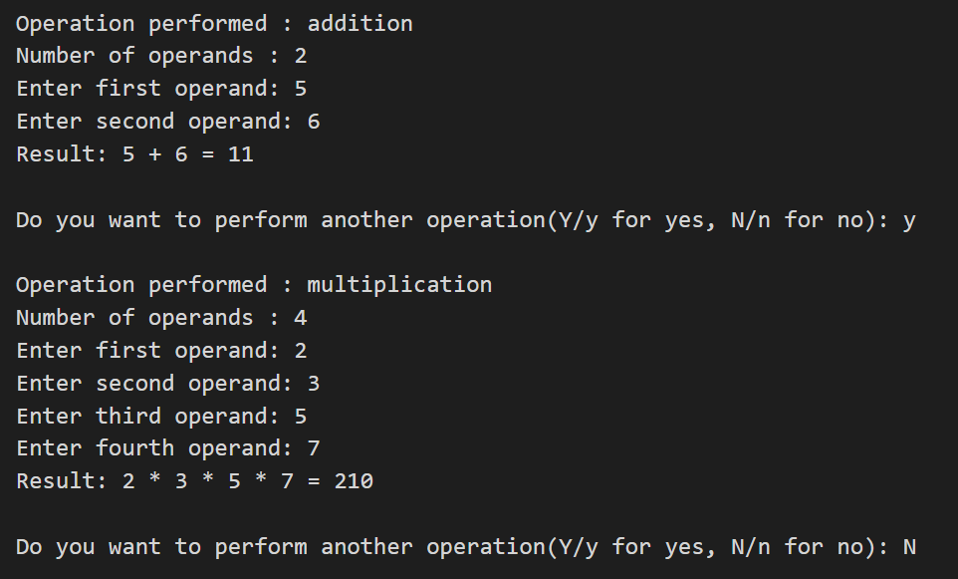

**Task # 02**

Create a class named shape that have a function named area(). Calculate the area of square and rectangle using method overloading.

* Square. Area = a2.
* Rectangle. Area = w × h.

**Task # 03**

Consider a scenario where Bank is a class that provides a method to get the rate of interest. However, the rate of interest may differ according to banks. For example, Bank A, Bank B, and Bank C are providing 8.4%, 7.3%, and 9.7% rate of interest. Calculate the ROI according to respective bank using method overriding.

**Task # 04**

A company pays its employees on a weekly basis. The employees are of four types:

* Salaried employees are paid a fixed weekly salary regardless of the number of hours worked
* Hourly employees are paid by the hour and receive overtime pay (i.e., 1.5 times their hourly salary rate) for all hours worked in excess of 40 hours,
* Commission employees are paid a percentage of their sales
* Base-salaried commission employees receive a base salary plus a percentage of their sales.

For the current pay period, the company has decided to reward salaried-commission employees by adding 10% to their base salaries. The company wants to write an application that performs its payroll calculations polymorphically.

**Task 05**

Write the codes for all the classes shown in the class diagram below.

